TASK : 1
Name: PARSHV PATEL
Enrollment No: 2402031000043
Sub : Web Technology with UI/UX
Course Code: 2010043228
Semester: 4th IT A-1

TASK–1: Creating Git Repository and Folder Structure
Step 1: Created GitHub Account
I created an account on GitHub using my email ID and logged in successfully.
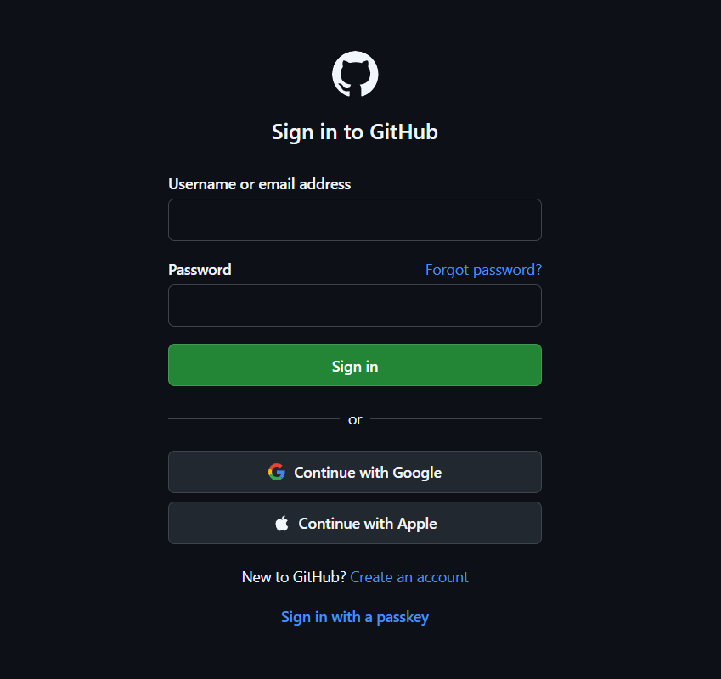
Screenshot 1: GitHub Login Page
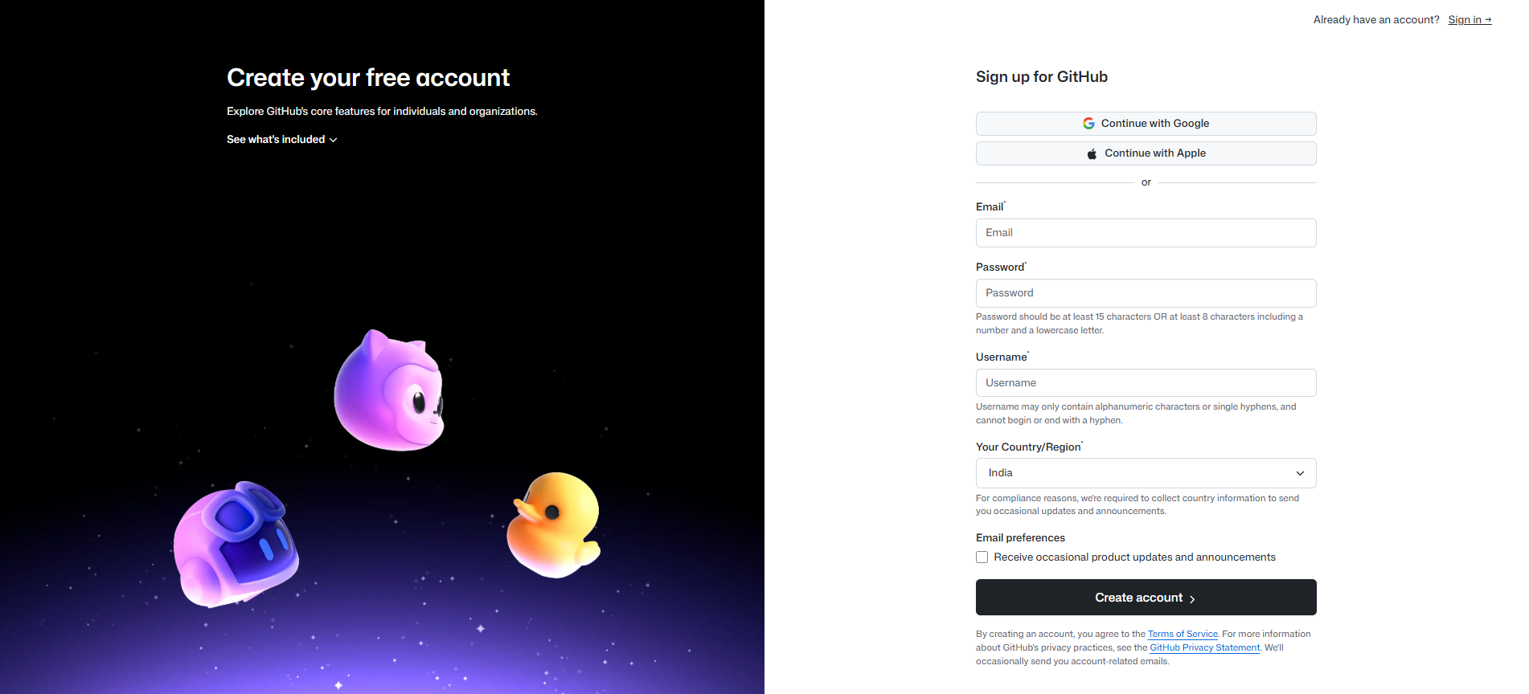
Step 2: Created Repository
I created a new repository on GitHub with my Enrollment Number as the repository name.
Repository Settings:
- Repository Name: (Your Enrollment Number)
- Visibility: Public
- Initialized with README
Screenshot 2: Repository Creation Page
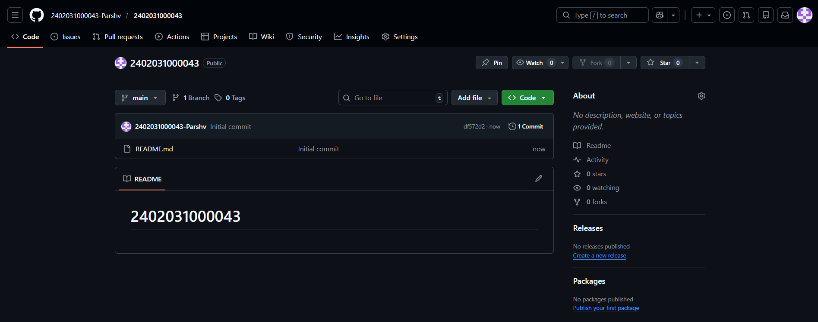
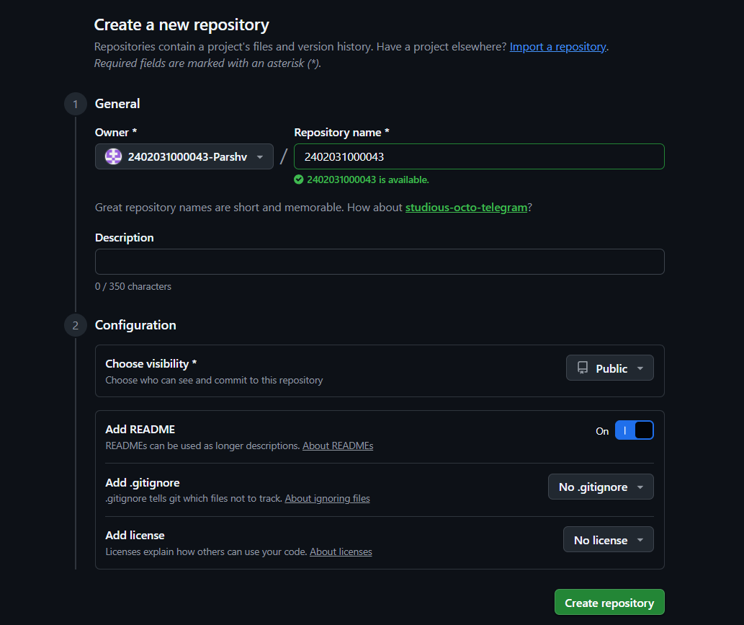
Step 3: Created Assignment_1 Folder
Inside the repository, I created a folder named Assignment_1 using Add File → Create New File → Assignment_1/readme.txt.
Screenshot 3: Assignment_1 Folder Created
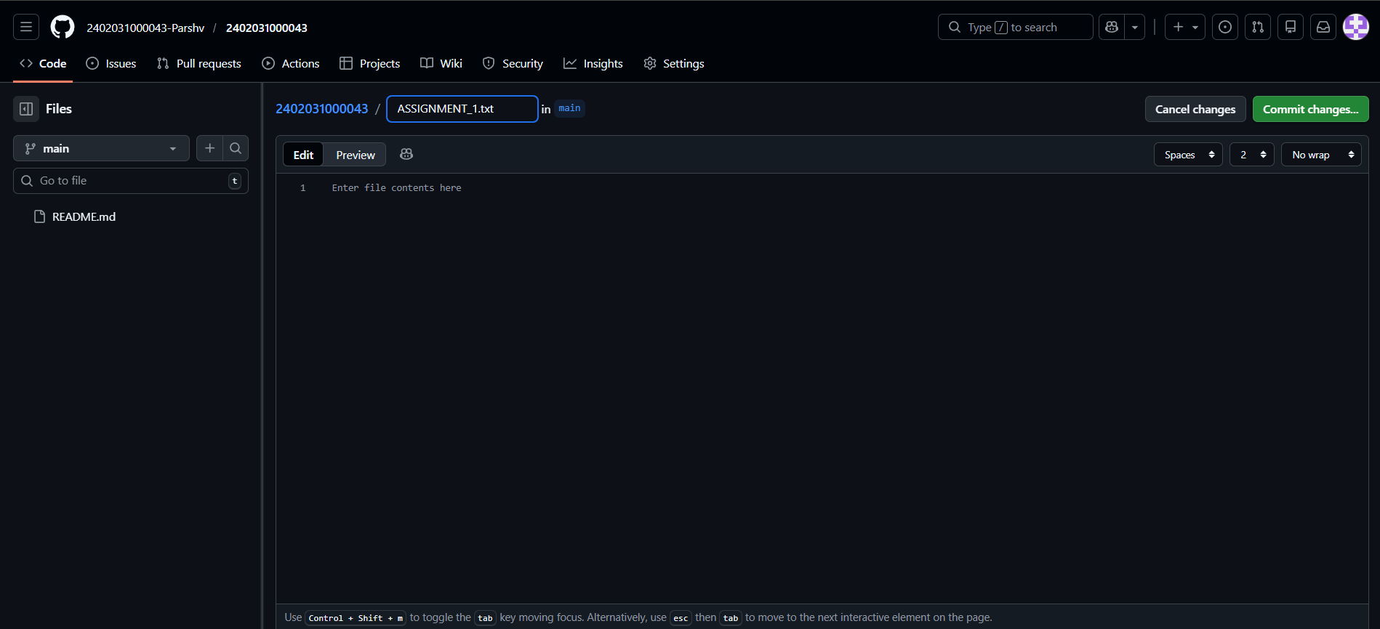
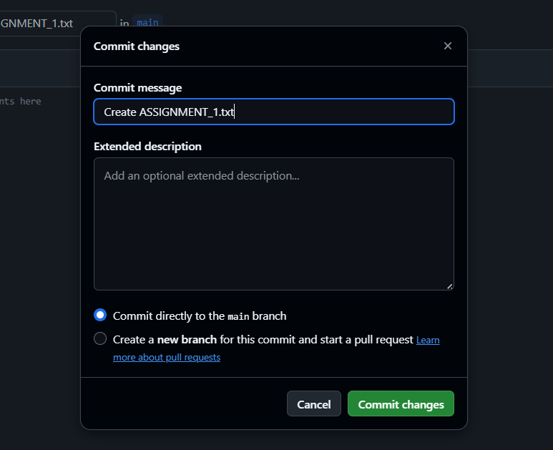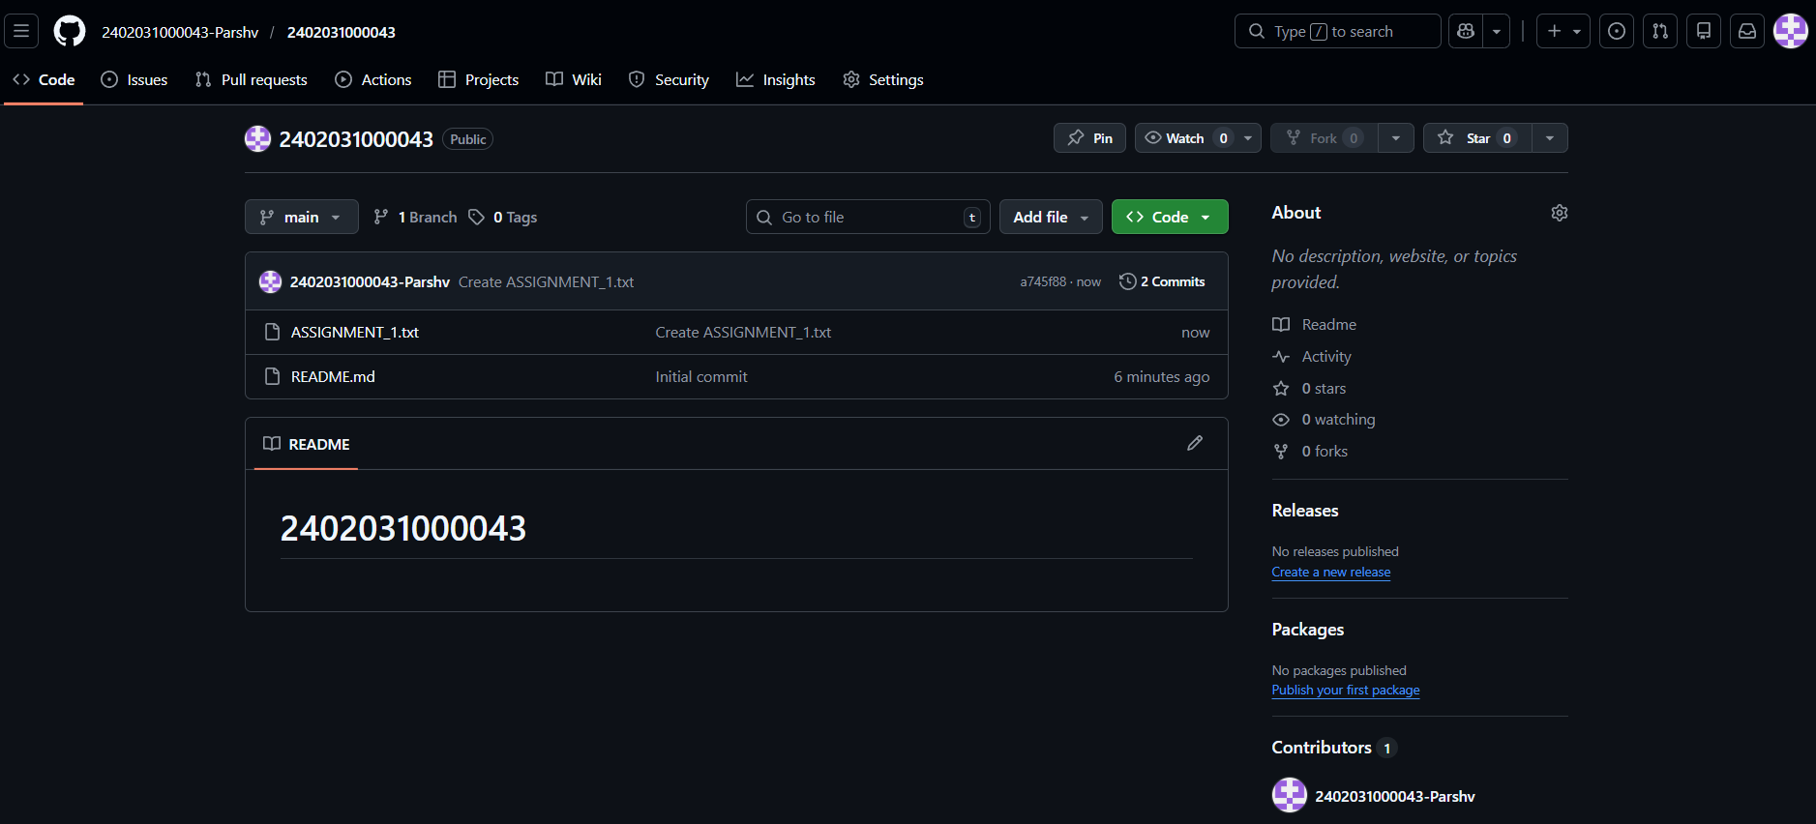
Step 4: Created Assignment_2 Folder
Similarly, I created another folder named Assignment_2.
Screenshot 4: Assignment_2 Folder Created
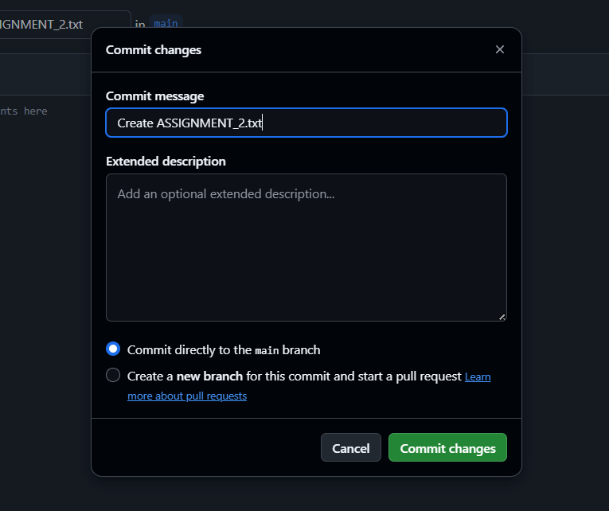
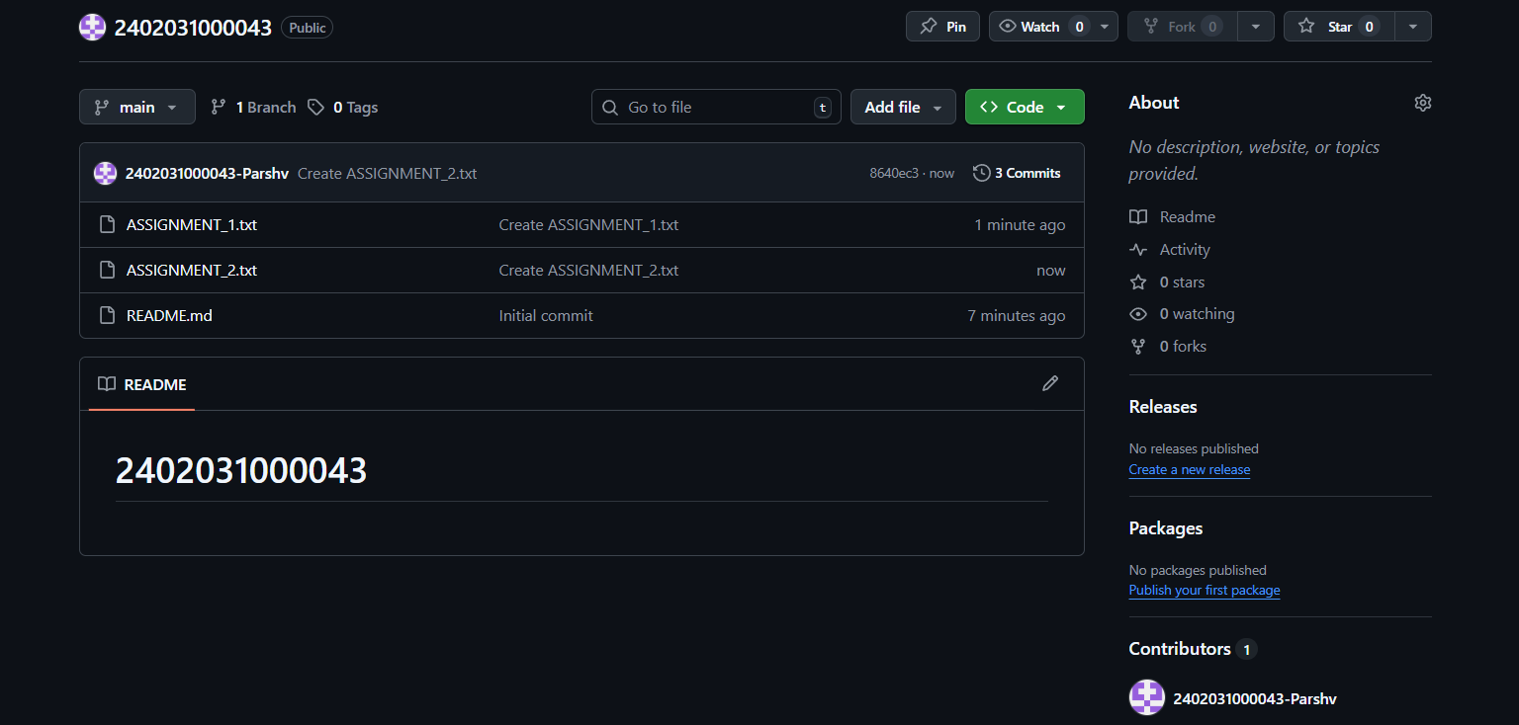
Thank You
Submitted To: Mr. Naimish Patel

